Line Chart

Definition
# Source: AI Source: Provided by: [Data Path: Persons Table -> ID Column: 1, Name_En Column: Motasem Essam] -> From: [Chatgpt (GPT‑5 Mini)] on [12/10/2025]
A Line Chart is a type of data visualization that displays data points connected by straight lines. It is commonly used to show trends, patterns, and changes over time.

Key Idea
# Source: AI Source: Provided by: [Data Path: Persons Table -> ID Column: 1, Name_En Column: Motasem Essam] -> From: [Chatgpt (GPT‑5 Mini)] on [12/10/2025]
Line charts are ideal for continuous data, where the order of the x-axis values matters (e.g., time series data). They help visualize trends, increases, decreases, and fluctuations clearly.

How It Works
# Source: AI Source: Provided by: [Data Path: Persons Table -> ID Column: 1, Name_En Column: Motasem Essam] -> From: [Chatgpt (GPT‑5 Mini)] on [12/10/2025]
- Place the independent variable (e.g., time) on the x-axis.
- Place the dependent variable (e.g., sales, temperature) on the y-axis.
- Plot data points for each x-y pair.
- Connect the points with lines to show the trend.

Example
# Source: AI Source: Provided by: [Data Path: Persons Table -> ID Column: 1, Name_En Column: Motasem Essam] -> From: [Chatgpt (GPT‑5 Mini)] on [12/10/2025]
Dataset: Monthly Sales
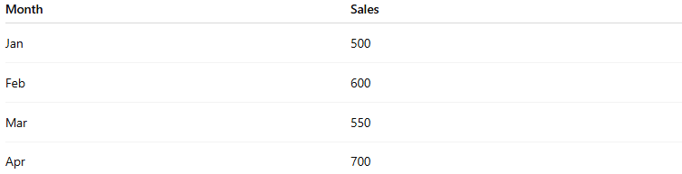
Month | Sales
Jan | 500
Feb | 600
Mar | 550
Apr | 700
Line Chart Representation:
- x-axis = Months
- y-axis = Sales
- Points plotted for each month connected by a line to show sales trend over time
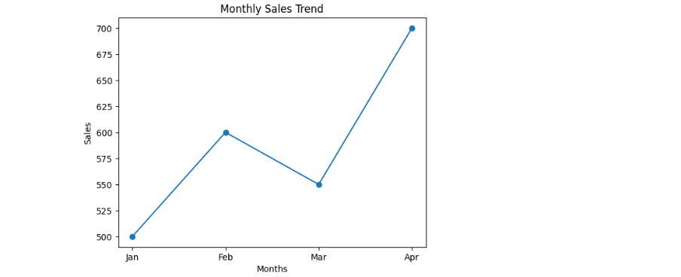

Applications
# Source: AI Source: Provided by: [Data Path: Persons Table -> ID Column: 1, Name_En Column: Motasem Essam] -> From: [Chatgpt (GPT‑5 Mini)] on [12/10/2025]
- Time series analysis (sales, stock prices, temperature)
- Detecting trends and patterns
- Forecasting future values
- Comparing multiple series on the same chart

Advantages
# Source: AI Source: Provided by: [Data Path: Persons Table -> ID Column: 1, Name_En Column: Motasem Essam] -> From: [Chatgpt (GPT‑5 Mini)] on [12/10/2025]
- Clearly shows trends and patterns over time
- Can handle multiple series for comparison
- Easy to interpret ups and downs in data

Disadvantages
# Source: AI Source: Provided by: [Data Path: Persons Table -> ID Column: 1, Name_En Column: Motasem Essam] -> From: [Chatgpt (GPT‑5 Mini)] on [12/10/2025]
- Less effective for categorical data
- Can become cluttered with many lines
- Outliers may distort the trend perception

